**Theatre Royal Windsor**

**Technical Information**

32 Thames Street, Windsor, SL4 1PS

01753 863444

[technical@theatreroyalwindsor.co.uk](mailto:technical@theatreroyalwindsor.co.uk)

**STAGE**

**Measurements**

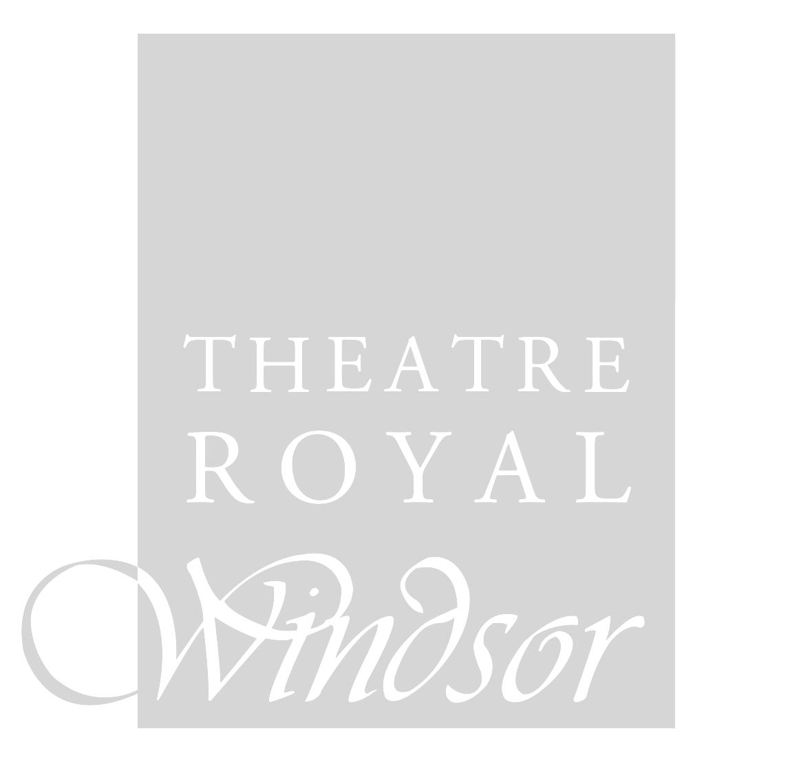**Rake 1:24**

**Depth** Front of stage to back wall **9800mm**

**Width** Prosc Opening **8530mm**

Flyfloor to Flyfloor **11000mm**

S/L Wall to S/R Wall **13700mm**

**Height** Prosc **5150mm**

To Grid **15160mm-15420mm**

To Underside of S/R Flyfloor **6900mm** (DS)

**6330mm** (US)

To Underside of S/L Flyfloor **6990mm** (DS)

**6670mm** (US)

**Playing Space**

18mm Hardboard floor painted black. Any changes to the stage flooring will be made good at the end of the run, at cost to the visiting company.

**Masking**

* 6x Full Width Borders of varying depths
* 2x Pairs of Legs 7x2m (DxW)
* 2x Pairs of Legs 10x1.5m (DxW)
* 1x Pair of legs 7x1.5m (DxW)
* Various Hard Maskers

**Flying**

* 35x Hemp Sets to SR Flyfloor, 150kg SWL
* 1x Fixed position LX Truss flown on Chain Hoists D/S of Bar 1, Max UDL 500kg
* 5x Variable position LX trusses flown on Chain Hoists. Max UDL 375kg each
* 4x Temporary Counterweights, these take up to four hours to pre rig and will be recharged back to the visiting company
* LED Starcloth is a permanent fixture, flown on Bar 35

**Get In**

Dock door – **2380x3050mm** (WxH) Door height from street level – **760mm**

**Orchestra Pit**

The orchestra pit measures **8300mm** wide. Seating row AA must be removed to use pit.

**Dressing Rooms**

**Stage Level**

Dressing Room Left 3 people

Dressing Room Right 3 people

*(Both dressing rooms have showers)*



**First Floor**

Dressing Room 1 3 people

Dressing Room 2 3 people

Dressing Room 3 2 people

**Second Floor**

Dressing Room 4 3 people

Dressing Room 5 3 people

Dressing Room 6/CO 2 people

**Third Floor**

Laundry Room

Dressing Room 7 5 people

Dressing Room 8 5 people

**Wardrobe**

Wardrobe facilities are available and will be recharged to the visiting company. Please contact the Technical and Production Manager if you require the use of wardrobe facilities.

**LIGHTING**

(All lanterns are fitted with maximum permissible wattage lamps)

**Profiles**

18x ETC Source4 Profile 14˚

12x ETC Source4 25/50 Zoom

4x ETC Source4 15/30 Zoom

30x ETC Source 4 Profile Body (750w)

-choice of 16x**19**˚, 23x**26**˚, 16x**36**˚,

14x**50**˚ lens tubes

**Fresnels**

28x ETC Source4 Fresnel (750w)

8x Strand Cantata (1200w)

4x Alto 2K

**Other**

50x Par64 (mainly CP62)

10x Floorcan

8x 4-cell Coda Flood

8x 1K ADB Flood

1x Atomic 3000 Strobe

**Effects** *(recharges for fluid)*

2x Unique 2.1 Hazer

1x Le Maitre G-Force Smoke Machine

1x LED Starcloth (White Only)

**Follow Spots**

2x Robert Juliet Korrigan

**Colour and Gobos**

We carry a quantity of colour and gobos which will be recharged to the visiting company.

**Lighting Control**

* ETC Ion with 1024 outputs
* 2x 20 Fader Wing
* 2x Universe DMX distributions around Stage and Flys
* Tablet Remote



**Dimmers**

216x total ways of ETC Sensor3 dimming; 209x **2.3kW** circuits, 7x **5.0kW** circuits.

**FOH Dimmer Locations**

*NB 40x dimmers required to feed FOH units individually*

4x circuits in spot box

6x circuits above circle doors, house left

6x circuits above circle doors, house right

4x circuits across circle front

6x circuits in top box, house left

6x circuits in top box, house right

4x circuits on prosc truss, house left

4x circuits on prosc truss, house right

Additional circuits, hot power and additional DMX tie lines can be run from stage to FOH. Please contact our Head of Lighting and/or Technical & Production Manager to discuss your requirements.

**Power Supplies**

Scene Dock – 1x 63A(1) and 1x 63A(3)

Scene Dock – 1x 125A(3) and 3x 32A(3)

Stage Right – 2x 16A(1)

We stock various jumper cables and distro blocks. Please request more information if required.

**SOUND**

**Patch**

There is a fully patchable 48/24way multi which terminates at the back of Royal Stalls (mix position).

On stage patch: DSR 6 XLR 2x Speakon

DSL 6 XLR 2x Speakon

USC 12 XLR 2x Speakon

PIT 12 XLR 2x Speakon

DSR 16 XLR

(patch bay located substage by amp racks)

**Control**



* Yamaha MG20XU (playback desk for plays)
* DiGiCo SD9 w/D2 rack (recharges apply for use of this desk)
* Symetrix Prism 16x16 Matrix Processor

**Speaker Locations**

Our sound system is fully timed, tuned and set-up for our auditorium.

**Stalls**

4x D&B E3 (fixed to front of stage)

2x Martin WT3

2x Martin WSX Subs (at bottom of prosc trusses)

2x EM Acoustics Quake (located in orchestra pit)

**Royal Stalls**

2x D&B E3 (stalls delays)

**Circle**

2x Martin WT3

**Surrounds**

6x JBL Control 1pro (spread across rear and sides of Royal Stalls)

2x JBL Control 1pro (located at approx. Row C of Circle)

**Playback and Effects**

1x Denon DEDN C620 CD Player

**Communication and Cueing**

TecPro Wired Comms System; 10 ways, more ways available at cost

Cuelight System; GDS 12 ways inc. LX and Flys